Questions/Exercises for final

- What are the differences between composition and inheritance?
One of the fundamental activities of any software system design is establishing relationships between classes. Two fundamental ways to relate classes are inheritance and composition. Although the compiler and Java virtual machine (JVM) will do a lot of work for you when you use inheritance, you can also get at the functionality of inheritance when you use composition.
Inheritance- one class (subclass) extends other class (superclass)
class Fruit {

//...
}

class Apple extends Fruit {

//...
}

Composition- one class is an instance variable of another class
class Fruit {

//...
}

class Apple {

private Fruit fruit = new Fruit();
//...
}
In the example above, class Apple is related to class Fruit by composition, because Apple has an instance variable that holds a reference to a Fruit object. In this example, Apple is what I will call the front-end class and Fruit is what I will call the back-end class. In a composition relationship, the front-end class holds a reference in one of its instance variables to a back-end class. In the composition approach, the subclass becomes the "front-end class," and the superclass becomes the "back-end class." With inheritance, a subclass automatically inherits an implementation of any non-private superclass method that it doesn't override. With composition, by contrast, the front-end class must explicitly invoke a corresponding method in the back-end class from its own implementation of the method. This explicit call is sometimes called "forwarding" or "delegating" the method invocation to the back-end object.
So how exactly do composition and inheritance compare? Here are several points of comparison:
- It is easier to change the interface of a back-end class (composition) than a superclass (inheritance). As the previous example illustrated, a change to the interface of a back-end class necessitates a change to the front-end class implementation, but not necessarily the front-end interface. Code that depends only on the front-end interface still works, so long as the front-end interface remains the same. By contrast, a change to a superclass's interface can not only ripple down the inheritance hierarchy to subclasses, but can also ripple out to code that uses just the subclass's interface.
- It is easier to change the interface of a front-end class (composition) than a subclass (inheritance). Just as superclasses can be fragile, subclasses can be rigid. You can't just change a subclass's interface without making sure the subclass's new interface is compatible with that of its supertypes. For example, you can't add to a subclass a method with the same signature but a different return type as a method inherited from a superclass. Composition, on the other hand, allows you to change the interface of a front-end class without affecting back-end classes.
- Composition allows you to delay the creation of back-end objects until (and unless) they are needed, as well as changing the back-end objects dynamically throughout the lifetime of the front-end object. With inheritance, you get the image of the superclass in your subclass object image as soon as the subclass is created, and it remains part of the subclass object throughout the lifetime of the subclass.
- It is easier to add new subclasses (inheritance) than it is to add new front-end classes (composition), because inheritance comes with polymorphism. If you have a bit of code that relies only on a superclass interface, that code can work with a new subclass without change. This is not true of composition, unless you use composition with interfaces. Used together, composition and interfaces make a very powerful design tool. I'll talk about this approach in next month's Design Techniques article.
- The explicit method-invocation forwarding (or delegation) approach of composition will often have a performance cost as compared to inheritance's single invocation of an inherited superclass method implementation. I say "often" here because the performance really depends on many factors, including how the JVM optimizes the program as it executes it.
- With both composition and inheritance, changing the implementation (not the interface) of any class is easy. The ripple effect of implementation changes

- What is polymorphism. Give a brief example.
http://download.oracle.com/javase/tutorial/java/IandI/polymorphism.html
Polymorphism is a term that describes a situation where one name may refer to different methods. In java there are two type of polymorphism: overloading type and overriding type.
When you override methods, java determines the proper methods to call at the program’s run time, not at the compile time. Overriding occurs when a class method has the same name and signature as a method in parent class. Overloading occurs when several methods have same names with different method signature. Overloading is determined at the compile time.
Example: Overloading
Class Book{
String title;
String publisher;
float price;
setBook(String title){
}
setBook(String title, String publisher){
}
setBook(String title, String publisher,float price){
}
}
Example: Overriding
Class Tool{
void operate_it(){
}
}
Class ScrewDriver extends Tool{
void operate_it(){
}
}

A polymorphic variable can appear to change its type
through dynamic binding.
 The compiler always understands a variable’s type
according to its declaration.
 The compiler permits some flexibility by way of type
conformance.
 At run-time the behavior of a method call depends upon
the type of the object and not the variable.

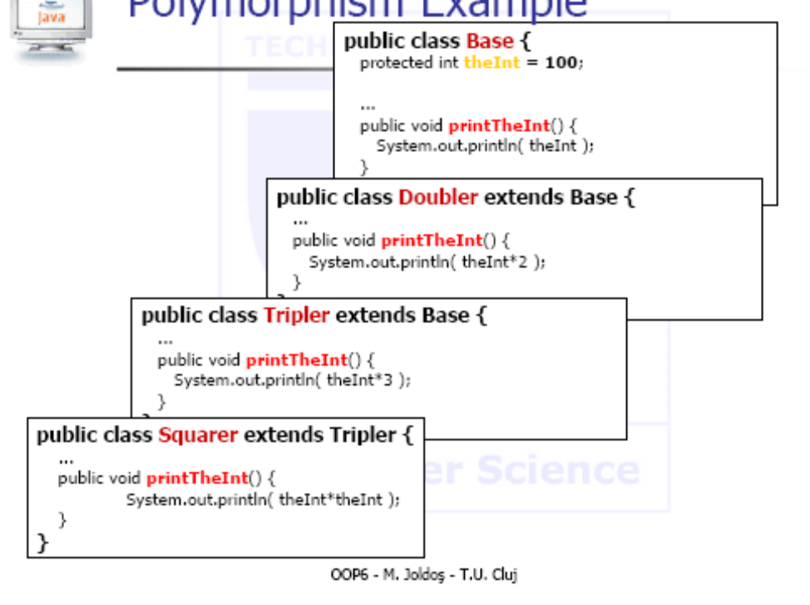
Base theBase;
theBase = new Base();
theBase.printTheInt();
theBase = new Doubler();
theBase.printTheInt();
theBase = new Tripler();
theBase.printTheInt();
theBase = new Squarer();
theBase.printTheInt();
theBase = new Base();
theBase.printTheInt();
...
100
200
300
10000
100

- What is the difference between overriding and overloading. Give brief examples.
Do not confuse overriding a method in a derived class with overloading a method name
When a method is overridden, the new method definition given in the derived class has the exact same number and types of parameters as in the base class
When a method in a derived class has a different signature from the method in the base class, that is overloading
Note that when the derived class overrides the original method, it still inherits the original method from the base class as well

- Given classes A, B, and C, where B extends A, and C extends B, and where all classes implement the instance method void doIt() . How can the doIt() method in A be called from an instance method in C? Why?
Within the definition of a method of a derived class, the base class version of an overridden method of the base class can still be invoked using super. However, repeating super will not invoke a method from some other ancestor class. So, A being the ancestor of B and B being the ancestor of C, from C we can invoke doIt form B using super, but cannot access doIt form A. (super.super.doIt() //Illegal)
We may use an instance of A in C ( A aux=new A()), and call aux.doIt().

- What would be the result of compiling and running the following program?
// Filename: MyClass. java
public class MyClass {
public static void main(String[] args) {
C c = new C();
System.out.println(c. max(13, 29));
}
}
class A {
int max(int x, int y) { if (x>y) return x; else return y; }
}
class B extends A{
int max(int x, int y) { return super.max(y, x) - 10; }
}
class C extends B {
int max(int x, int y) { return super.max(x+10, y+10); }
}
The result will be 29.
First it will call the max method from C, this will call the max method from B with parameters 39,23, this will call the max method from A and return 39 then subtract 10 => 29
- Which is the simplest expression that can be inserted at (1), so that the program prints the value of the text field from the Message class?
// Filename: MyClass.java
class Message {
// The message that should be printed:
String text = "Hello, world! ";
}
class MySuperclass {
Message msg = new Message() ;
}
public class MyClass extends MySuperclass {
public static void main(String[] args) {
MyClass object = new MyClass();
object.print();
}
public void print() {
System.out.println( /* (1) WRITE THIS COMPLETED STATEMENT */ ) ;
}
}
(1) super.msg.text
- Which method declarations, when inserted at (7), will not result in a compile-time error?
class MySuperclass {
public Integer step1(int i) { return 1; } // (1)
protected String step2(String str1, String str2) { return str1; } // (2)
public String step2(String str1) { return str1; } // (3)
public static String step2() { return "Hi "; } // (4)
public MyClass makeIt() { return new MyClass(); } // (5)
public MySuperclass makeIt2() { return new MyClass(); } // (6)
}
public class MyClass extends MySuperclass {
// (7) WRITE THIS METHOD DECLARATION
}
None of them give any errors:
public Integer step1(int i) { return 1; }
protected String step2(String str1, String str2) { return str1; }
public String step2(String str1) { return str1; } // (3)
public static String step2() { return "Hi "; } // (4)
public MyClass makeIt() { return new MyClass(); } // (5)
public MySuperclass makeIt2() { return new MyClass(); } // (6)
- What would be the result of compiling and running the following program?
class Vehicle {
static public String getModelName() { return "Volvo"; }
public long getRegNo() { return 12345; }
}
class Car extends Vehicle {
static public String getModelName() { return "Toyota"; }
public long getRegNo() { return 54321; }
}
public class TakeARide {
public static void main(String args[]) {
Car c = new Car();
Vehicle v = c;
System.out.printl n("| " + v.getModelName() + "| " + c. getModel Name() +
"| " + v.getRegNo() + "| " + c. getRegNo() + "| ");
}
}
Output: | Volvo| Toyota| 54321| 54321|

if we didn’t have the static keyword at getModelName: Output: | Toyota| Toyota| 54321| 54321|

if we had static at both methods:
Output: | Volvo| Toyota| 12345| 54321|
- What would be the result of compiling and running the following program?
final class Item {
Integer size;
Item(Integer size) { this. size = size; }
public boolean equals(Item item2) {
if (this == item2) return true;
return this.size.equals(item2.size);
}
}
public class SkepticRide {
public static void mai n(String[] args) {
Item itemA = new Item(10);
Item itemB = new Item(10);
Object itemC = itemA;
System.out.printl n("| " + itemA.equal s(itemB) +
"| " + itemC.equal s(itemB) + "| ") ;
}
}
Output: | true| false|
First comparison : true
This==item2 never true in this case (no two objects referring to the same object) Result given by this.size.equals(item2.size); 10==10 => true
Second comparison : false
ItemC is of type Object so the equals method from Object is called, not the one we defined. => false. If ItemC was of type Item the result would have been true;
If one of the objects from a comparison is of type Object, the method called is not the one we defined but the implicit one defined for class Object.
In Java, the equals method can be considered to perform a deep comparison of the value of an object, whereas the == operator performs a shallow comparison. The equals method compares the content of two objects rather than two objects' references. The == operator with reference types (i.e., Objects) evaluates as true if the references are identical - point to the same object. With value types (i.e., primitives) it evaluates as true if the value is identical. The equals method is to return true if two objects have identical content - however, the equals method in the java.lang.Object class - the default equals method if a class does not override it - returns true only if both references point to the same object.

- Which constructors can be inserted at (1) in MySub without causing a compile-time error?
class MySuper {
int number;
MySuper(int i) { number = i ; }
}
class MySub extends MySuper {
int count;
MySub(int count, int num) {
super(num);
this.count = count;
}
// (1) WRITE CONSTRUCTOR NEEDED At THIS POINT
}
MySub(){
this(0,0);
}

- What will the following program print when run?
// Filename: MyClass.java
public class MyClass {
public static void main(String[] args) {
B b = new B("Test");
}
}
class A {
A() { this("1", "2"); }
A(String s, String t) { this(s + t); }
A(String s) { System.out.printl n(s); }
}
class B extends A {
B(String s) { System.out.printl n(s); }
B(String s, String t) { this(t + s + "3"); }
B() { super("4"); };
}
Output:
12
Test
If a derived class constructor does not include an invocation of super, then the no-argument constructor of the base class will automatically be Invoked.=> first print 12 from constructor A(), then test
This can result in an error if the base class has not defined a no-argument constructor.
12. Consider the following two class definitions.
class X {
public double g(double x) {
return f(x) * f(x);
}
public double f(double x) {
return x + 1.0;
}
}
class Y extends X {
public double f(double x) {
return x + 2.0;
}
}
What will the following sequence of statements print?
Y y = new Y();
X x = y;
System.out.println(y.f(2.0));
System.out.println(x.f(2.0));
System.out.println(x.g(2.0));
Output
4
4
16
The f method is overridden in X. Both x and y point to the same object of type Y.
13. Suppose a user executes the following run() method and types the numbers 5 and 22.
public static void run() {
int a = IO.readInt();
int b = IO.readInt();

int m = 0;
int n = b;
while(m < n) {
m += a;
n -= a;
}
System.out.println(m - n);
}
Show all the values taken on by the variables of the program.
a 5
b 22
m 0 5 10 15
n 22 17 12 7
What does the method print?
8
- Complete the below class method so that it reads two strings from the user and displays "yes"' if the second string includes only characters from the first, and "no"' if it contains any characters that the first does not include. For example, I should be able to execute your method and see the following. (Boldface indicates what the user types.)
brillig glib
yes
Or I might see the following. In this example, it prints "no" because broil includes the letter o, which does not occur in brillig.
brillig broil
no
public static void run() {
Scanner in = new Scanner(System.in);
String s1=in.nextLine();
String s2=in.nextLine();
int marker[]=new int[s1.length()];
int ls1=s1.length();
int ls2=s2.length();
int j=0;
boolean ok=true;
for(int i=0;i<ls2 && ok;i++)
{
char c=s2.charAt(i);
j=0;
while((j<ls1)&&(ok=true)){
if((s1.charAt(j)==c)&&(marker[j]==0)){
marker[j]=1;
j=ls1+1;
}
j++;
}
if(j==ls1) ok=false;
}
if(ok) System.out.println("yes");
else System.out.println("no");
}To accomplish this, you may find the following String instance methods useful.
int length()
Returns the number of characters in the target string.
char charAt(int i)
Returns the character at index i. For example, if str holds the string brillig, str.charAt(2) would return the character 'i'.
int indexOf(String s)
Returns the index where s occurs first within the string on which the method is called. If s occurs nowhere within the target string, the method returns -1. For example, if str holds the string brillig, str.indexOf("il") would return 2, since this is the index where il occurs first.

- At right, write a definition of a new type, called IntRange, representing a range of integers. This class should support the following instance methods.
IntRange(int start, int end)
(Constructor method) Sets up a new IntRange object representing the set of integers between start and end, including these two endpoints. The method may assume that the first parameter is below or equal to the second parameter.
int getSize()
Returns the number of integers in the range.
boolean contains(int i)
Returns true if i lies within the range.
The following example method, which uses the IntRange class you define, illustrates how the class should work.
public static void run() {
IntRange range = new IntRange(2, 4);
System.out.println(range.getSize()); // this prints ``3''
System.out.println(range.contains(1)); // this prints ``false''
System.out.println(range.contains(3)); // this prints ``true''
System.out.println(range.contains(4)); // this prints ``true''
System.out.println(range.contains(5)); // this prints ``false''
}
public class IntRange {
private int start;
private int end;
public IntRange(int start, int end){
this.start=start;
this.end=end;}
int getSize(){
return end-start+1;}
boolean contains(int i){
if((start<=i)&&(i<=end))return true;
else return false;}}
- Suppose we have the following two class definitions.
class A {  public int f(int x) {  return 2 * x;  }  public int g(int x) {  return f(x * 3);  }  } | class B extends A {  public int f(int x) {  return 5 * x;  }  public int h(int x) {  return f(7 * x);  }  }
And suppose we execute the following run method.
public static void run() {
B b = new B();
System.out.println(b.f(1) + " " + b.g(1) + " " + b.h(1));
A a = b;
System.out.println(a.f(1) + " " + a.g(1));
}
What would the method print?
Output 5,15,35
5,15
(Method f from A is overridden in B)

- Define a class PassCount to track whether all the students of a class have passed a test. It should support the following methods.
PassCount()
(Constructor method) Constructs an object representing an empty class.
void addGrade(double grade) Adds grade into the class.
boolean isAnyFailing() Returns true only if there is somebody in the class who received a grade of less than 60.
For example, if you defined this class properly, I should be able to write the following class to test it.
public class PassCountTest {
public static void run() {
PassCount a = new PassCount();
addGrade(45.0);
addGrade(76.0);
System.out.println(a.isAnyFailing()); // should print "true"

PassCount b = new PassCount();
addGrade(60.0);
System.out.println(b.isAnyFailing()); // should print "false"
}
}
Note that, to accomplish this, a PassCount object need not remember every single grade --- that is, you do not need to use arrays: It just needs to remember whether any of the ones it has seen were below 60.
Public class PassCount{
Private boolean fail=false;
Public PassCount(){
fail=false;
}
void addGrade(double grade){
if(grade<60) fail=true;
}
boolean isAnyFailing(){
return fail;
}

}

- Define a class NumberIterator for iterating through a sequence of numbers. It should support the following methods.
NumberIterator(int start, int stop)
(Constructor method) Constructs an object for iterating through the integers beginning at start and going up to stop. The constructor assumes that start is less than stop.
boolean hasMoreNumbers()
Returns true if there are more numbers remaining in the sequence.
int nextNumber()
Returns the current number in the sequence and steps the iterator forward, so that the next call to this method returns the following number in the sequence. This method initiates a NoSuchElementException if the sequence has no more elements remaining.
For example, if you defined this class properly, I should be able to write the following class to test it. When executed, its run() method would print "5 6 7 8".
public class NumberIteratorTest {
public static void run() {
NumberIterator it = new NumberIterator(5, 8);
System.out.print(it.nextNumber());
while(it.hasMoreNumbers()) {
int i = it.nextNumber();
System.out.print(" " + i);
}
}
}
public class NumberIterator{
private int start;
private int stop;
private int current;
public NumberIterator(int start, int stop){
this.start=start;
this.stop=stop;
current=start;
}
boolean hasMoreNumbers(){
if(current<=stop) return true;
else return false;
}
int nextNumber(){
current++;
return current-1;
//or just return current++;
}
}
- Suppose we have the following two class definitions.
class P {  public int f(int x) {  return x + 1;  }  public int g(int x) {  return f(x + 2);  }  } | class Q extends P {  public int f(int x) {  return x + 4;  }  public int h(int x) {  return f(x + 8);  }  }
And suppose we execute the following run method.
public static void run() {
P a = new P();
Q b = new Q();
P c = b;
System.out.println(a.f(0) + " " + a.g(0));
System.out.println(b.f(0) + " " + b.g(0) + " " + b.h(0));
System.out.println(c.f(0) + " " + c.g(0));
}
What would the method print?
Output:
1 3
4 6 12
4 6

- Suppose we have the class defined as below.
class C {  static int y = 0;  int z;  C() {  z = 0;  }  void incrX() {  int x = 0;  x++;  IO.println(x);  }  void incrY() {  y++;  IO.println(y);  }  void incrZ() {  z++;  IO.println(z);  }  } | public class Example {  public static void run() {  C a = new C();  C b = new C();  a.incrX();  a.incrX();  b.incrX();  a.incrY();  a.incrY();  b.incrY();  a.incrZ();  a.incrZ();  b.incrZ();  }  }
What would the computer print when it executes the Example class's run() method?
1
1
1
1
2
3
1
2
1
the static variable Y is common for all the objects instantiated from this class.

- A matrix is symmetric if, for each i and j, a_{i,j} = a_{j,i}. The following is an example of a symmetric matrix.
0 | 23 | 45
23 | 10 | 36
46 | 36 | 20
Another way of defining it: A symmetric matrix can be reflected across its main diagonal (top left corner to bottom right corner) to obtain the same matrix.
Complete the following method so that it returns true only if the two-dimensional array parameter mat is symmetric. Your solution may assume that the matrix is square (as many columns as rows).
public static boolean isSymmetric(int[][] mat) {
boolean ok=true;
for(int i=0; i<mat.length;i++)
for (int j=0;j<i-1;j++)
if(a[i][j]!=a[j][i]) ok=false;
return ok;
}
(Your solution shouldn't really be this long!)

- Define a class PigPen for tracking the number of pigs in in a pen. It should support the following methods.
PigPen(int pigs)
(Constructor method) Constructs an object representing a pig pen containing pigs pigs.
boolean isEmpty()
Returns true if there are no pigs in the pen.
void pigEnters()
Adds one to the number of pigs in the pen.
void pigExits()
Subtracts one from the number of pigs in the pen.
For example, if you defined this class properly, I should be able to write the following class to test it.
public class PigPenTest {
public static void run() {
PigPen pen = new PigPen(2);
pen.pigExits();
System.out.println(pen.isEmpty()); // prints "false"
pen.pigExits();
System.out.println(pen.isEmpty()); // prints "true"
pen.pigEnters();
System.out.println(pen.isEmpty()); // prints "false"
}
}
public class PigPen{
private int pigs=0;
public pigpen(int pigs){
this.pigs=pigs;
}
void pigEnters(){
pigs++;
}
void pigExits(){
pigs--;
}
boolean isEmpty(){
return (pigs==0);
}
}
- Write a class method named mode that takes an array of ints as a parameter and returns the integer that occurs in the array most frequently. For example, the following code fragment that uses your mode method should print 23.
int[] a = { 23, 34, 45, 23, 0, 23 };
System.out.println(mode(a));

Your method should not call any other methods to accomplish this. It will need more than one loop to count the number of occurrences of each number in the array.
public static int mode(int[] a){
int max=0;
int n=a.length;
int lenAux=0;
int aux[]=new int[a.length];
int nraux[]=new int[a.length];
boolean ok=true;
for(int i=0;i<n;i++){
ok=false;
for(int j=0;j<lenAux;j++)
if(a[i]==aux[j]){
nraux[j]++;
ok=true;
}
if(ok==false){
lenAux++;
aux[lenAux]=a[i];
}
}
for(int i=0;i<lenAux;i++)
if(nraux[max]<nraux[i]) max=i;
return aux[max];
}
- Consider the following Java program.
class A {
int f() { return 1; }
}
class B extends A {
int f() { return 0; }
}
class Main {
public static void main(String[] args) {
A a = new B();
System.out.println(a.f());
}
}
What does this program print?
Output 0 => method f from the Objects base class, not type class.
- Consider the following program.
class Ident {
int f(int x) { return x; }
int g(int x) { return f(f(x)); }
}
class Square extends Ident {
int f(int x) { return x * x; }
}
class Main {
public static void main(String[] args) {
Ident a = new Ident();
Ident b = new Square();
Square c = new Square();
System.out.println(a.g(3) + " " + b.g(3) + " " + c.g(3));
}
}
What does this program print?
Output:3 81 81
=>f from class Square overrides method f from class Ident;
a.g(3) calls f from Ident, c.g(3) calls f from Square and b.g(3) calls f from Square even if type of b is Ident.

- Write an expression will extract the substring "kap", given the following declaration:
String str = "kakapo";
String str2=str.substring(2,5);
- What will be the result of attempting to compile and run the following code?
class MyClass {
public static void main(String[] args) {
String str1 = "str1";
String str2 = "str2";
String str3 = "str3";
str1.concat(str2) ;
System.out.println(str3.concat(str1));
}
}
Output : str3str1;
If we had str1=str1.concat(str2) the output would have been: str3str1str2
- What will be the result of attempting to compile and run the following program?
public class RefEq {
public static void mai n(String[] args) {
String s = "ab" + "12";
String t = "ab" + 12;
String u = new String("ab12");
System.out.println((s==t) + " " + (s==u));
}
}
Output: true false

String s and t point in the String Literal Pool to the same value ab12, while string u is a String object that is created out of the String literal pool, even if an equal string already exists in the pool.
So s==t (point to the same string) while s!=u (do not point to the same string).
- What is a Java exception?
An exception: a problem that occurs when a program is running.
 When an exception occurs, the JVM creates an object of class Exception which holds information about the problem.
 A Java program itself may catch an exception. It can then use the Exception object to recover from the problem.
 An error, also, is a problem that occurs when a program is running.
 An error is represented by an object of class Error.
 But an error is too severe for a program to handle. The program must stop running.

- How can done deal with exceptional conditions in Java. Give a short example.
Java library software (or programmer-defined code) provides a mechanism that signals when something unusual happens
 This is called throwing an exception
 In another place in the program, the programmer must provide code that deals with the exceptional case
 This is called handling the exception
throw new
ExceptionClassName(PossiblySomeArguments);

- Describe the thry-throw-catch mechanism.
The basic way of handling exceptions in Java consists of the try-throw-catch trio
 The try block contains the code for the basic algorithm
 It tells what to do when everything goes smoothly
 It is called a try block because it "tries" to execute the case where all goes as planned
 It can also contain code that throws an exception if something unusual happens
try {
CodeThatMayThrowAnException
}
throw new
ExceptionClassName(PossiblySomeArguments);
 When an exception is thrown, the execution of the surrounding try block is stopped
 Normally, the flow of control is transferred to another portion of code known as the catch block
 The value thrown is the argument to the throw operator, and is always an object of some exception class
 The execution of a throw statement is called throwing an exception
A throw statement is similar to a method call:throw new ExceptionClassName(SomeString);
 In the above example, the object of class ExceptionClassName is created using a string as its argument
 This object, which is an argument to the throw operator, is the exception object thrown
 Instead of calling a method, a throw statement calls a catch block
When an exception is thrown, the catch block begins execution
 The catch block has one parameter
 The exception object thrown is plugged in for the catch block parameter
 The execution of the catch block is called catching the exception, or handling the exception
 Whenever an exception is thrown, it should ultimately be handled (or caught) by some catch block
catch(Exception e) {
ExceptionHandlingCode
}
 A catch block looks like a method definition that has a parameter of type Exception class
 It is not really a method definition, however
 A catch block is a separate piece of code that is executed when a program encounters and executes a throw statement in the preceding try block
 A catch block is often referred to as an exception handler
 It can have at most one parameter
catch(Exception e) { . . . }
 The identifier e in the above catch block heading is called the catch block parameter
 The catch block parameter does two things:
1. It specifies the type of thrown exception object that the catch block can catch (e.g., an Exception class object above)
2. It provides a name (for the thrown object that is caught) on which it can operate in the catch block – Note: The identifier e is often used by convention, but any non-keyword identifier can be used
When a try block is executed, two things can happen:
1. No exception is thrown in the try block
– The code in the try block is executed to the end of the block
– The catch block is skipped
– The execution continues with the code placed after the catch block
2. An exception is thrown in the try block and caught in the catch block
– The rest of the code in the try block is skipped
– Control is transferred to a following catch block (in simple cases)
– The thrown object is plugged in for the catch block parameter
– The code in the catch block is executed
– The code that follows that catch block is executed (if any)

????????????????
- State the catch-or-declare rule.
If a checked exception may be thrown within the body of a method, the method must either catch the exception or declare it in its throws clause.
(**
http://en.wikibooks.org/wiki/Java_Programming/Throwing_and_Catching_Exceptions
When an exception is "thrown", the search for the first matching catch block/clause begins.
There are five main catching matching rules:
- A thrown exception object, can be caught by the catch keyword with specifying the exception object's class or its super-class.
- When there are a list of catch clauses, it is evaluated sequentially, applying the first rule. If there is a catch, the following catch clauses are ignored.
- If there is a catch clause in the list, which will never be executed, because its super-class are listed before it, the compiler will give an error message.
- The compiler enforce that all Exception and its sub-class exceptions must be handled by the programmer, except the RuntimeException and its sub-classes.
- If the try block would never throw an exception that is specified in the catch list, the compiler gives an error.
**)
Most ordinary exceptions that might be thrown within a method must be
accounted for in one of two ways:
1. The code that can throw an exception is placed within a try block, and the possible
exception is caught in a catch block within the same method
2. The possible exception can be declared at the start of the method definition by placing the
exception class name in a throws clause.

????????????????????
- How do exceptions propagate? Give a brief example.
If the Exception is declared with the throws clause, it shifts the exception handling responsibility to the method that invoked the exception throwing method. The invoking method must handle the exception, unless it too uses the same technique to "pass the buck". Ultimately, every exception that is thrown should eventually be caught by a catch block in some method that does not just declare the exception class in a throws clause.
If an exception is not declared, then it must be handled within the method. If an exception is declared, then the responsibility for handling it is shifted to some other calling method. Note that if a method definition encloses an invocation of a second method, and the second method can throw an exception and does not catch it, then the first method must catch or declare it.

When an exception is thrown by a statement in the try{} block, the catch{} blocks are examined one-by-one starting with the first.
_ Only one catch{} block is picked.
_ If no catch{} block matches the exception, none is picked, and execution leaves this method (just as if there were no catch{} block.)
_ The first catch{} block to match the type of the exception gets control.
_ The most specific exception types should appear first in the structure, followed by the more general exception types.
_ The statements in the chosen catch{} block execute sequentially. After the last statement executes, control goes to the first statement that follows the try/catch structure.
_ Control does not return to the try block.
public void doFileWork(String
filename) throws
DatabaseException{
FileOutputStream fos = null;
ObjectOutputStream oos = null;
try{
fos = new
FileOutputStream(filename);
oos = new
ObjectOutputStream(fos);
oos.writeObject(obj);
}
catch(IOException e){
throw new DatabaseException(
"Problem while working with
"+filename+": "
+e.getMessage());
}
finally{
try{
if(oos!=null){
oos.close();
}
if(fos!=null){
fos.close();
}
}
catch(IOException e){
throw new DatabaseException(
"Problem while working with
"+filename+": "
+e.getMessage());
}
}
}

??????????????????????????????
- What is the minimum a user-defined exception class must contain? Give a short example.
Every exception class to be defined must be a derived class of some already defined exception class
 It can be a derived class of any exception class in the standard Java libraries, or of any programmer defined exception class
 Constructors are the most important members to define in an exception class
 They must behave appropriately with respect to the variables and methods inherited from the base class
 Often, there are no other members, except those inherited from the base class
public class DivisionByZeroException extends Exception
{
public DivisionByZeroException()
{
super("Division by zero.");
}
public DivisionByZeroException(String message)
{
super(message);
}
}
Super is an invocation of the base class Exception
The two most important things about an exception object are its type (i.e., exception
class) and the message it carries
 The message is sent along with the exception object as an instance variable
 This message can be recovered with the accessor method getMessage, so that the
catch block can use the message

- What is an inner class?
A class definition within another class definition is called an inner class
 it allows you to group classes that logically belong together and to control the visibility of one within the other
 inner classes are distinctly different from composition
 To create an object of the inner class anywhere except from within a non-static method of the outer class, you must specify the type of that object as OuterClassName.InnerClassName
- What is an anonymous inner class? Give a short example.
An anonymous class is a local class that has no name.
EXAMPLES:
Timer object with anonymous ActionListener:
Timer timer = new Timer( 200, new ActionListener() {
public void actionPerformed(ActionEvent e)
{
// do something
}
});
Initialization using a final input parameter (each Object made will have the name that was used when makeObj() was called to make it.)
public MyClass makeObj(final String name)
{
return new SubClassOfMyClass() {
public String toString()
{
return "My name is "+name;
}
};
}
Initialization using final local variable
public Object makeObj(String name)
{
final String objName = "My name is " + name;
return new Object() {
public String toString()
{
return objName;
}
};
}
Initialization using initialization block
public Object makeObj(String name)
{
return new Object() {
String objName;
{
objName = "My name is " + name;
}
public String toString()
{
return objName;
}
};
}

- What is a local class? Give a short example.
Local classes are declared within a block of code and are visible only within that block, just as any other method variable.
interface MyInterface {
public String getInfo();
}
class MyOuter {
MyInterface current_object;
public void setInterface(String info) {
class MyInner implements MyInterface {
private String info;
public MyInner(String inf) {info=inf;}
public String getInfo() {return info;}
}
current_object = new MyInner(info);
}
}
- What is a Java component? Give a short example.
A Component is visual object containing text or graphics. Any descendent class of the class JComponent is called a component class

Example :JLabel, JButton.
- What is a Java container? Give a short example.
A Container is a graphical object that can hold components or other containers. The principal container is a Frame. It is a part of the computer screen surrounded by borders and title bars.
Any class that is a descendent class of the class Container is considered to be a container class
 The Container class is found in the java.awt package, not in the Swing library
 Any object that belongs to a class derived from the Container class (or its descendents) can have components added to it
 The classes JFrame and JPanel are descendent classes of the class Container
 Therefore they and any of their descendents can serve as a container

- What are the Basic steps in displaying Java Graphics?
To display Java graphics:
1. Create the component or components to display
2. Create a frame to hold the component(s), and place the component(s) into the frame(s).
3. Create a “listener” object to detect and respond to mouse clicks, and assign the listener
to the frame.
 Now we'll use components of class JPanel, and containers of class JFrame.
- What is a listener in Java?
A “listener” class listens for mouse clicks or keyboard input on a container or
component, and responds when it occurs.
- What is the purpose of call-backs?
Callback is a scheme used in event-driven programs where the program registers a
subroutine (a "callback handler") to handle a certain event.
 The program does not call the handler directly but when the event occurs, the
run-time system calls the handler, usually passing it arguments to describe the event.
??????????????
- What is the role of the model in the MVC architecture?
The model represents internally the data for the application.
Most programs are supposed to do work, not just be “another pretty face”
 but there are some exceptions
 useful programs existed long before GUIs
 The Model is the part that does the work – it models the actual problem being solved
 The Model should be independent of both the Controller and the View
 But it can provide services (methods) for them to use
 Independence gives flexibility, robustness

- What is the role of the controller in the MVC architecture?

The controller takes user input on the view and translates that to changes in the model.
The Controller decides what the model is to do
 Often, the user is put in control by means of a GUI
 in this case, the GUI and the Controller are often the same
 The Controller and the Model can almost always be separated(what to do versus how to do it)
 The design of the Controller depends on the Model
 The Model should not depend on the Controller

- What is the role of the view in the MVC architecture?
The view is the visual representation of the data
Typically, the user has to be able to see, or view, what the program is doing
 The View shows what the Model is doing
 The View is a passive observer; it should not affect the model
 The Model should be independent of the View, but (but it can provide access
methods)
 The View should not display what the Controller thinks is happening
- Briefly describe the Swing separable model architecture.
The view and controller parts of a component
required a tight coupling
 These two entities were collapsed into a single UI (userinterface)
object
 This new quasi-MVC design is sometimes referred to a
separable model architecture.
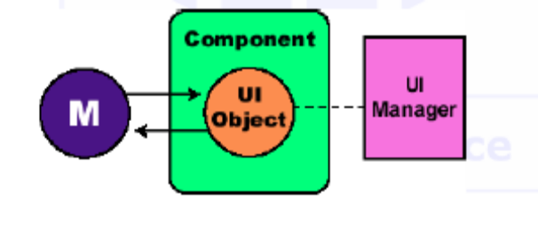

- What is a Java Enumeration? Give a small example.
There are objects used to step through a container.
To get an Enumeration e for container v:
 Enumeration e = v.elements();
 This is initialized at the start of the list.
 To get the first and subsequent elements:
 someObject = e.nextElement()
 To test if all have been accessed:
 e.hasMoreElements()
 Example:
for (Enumeration e = v.elements();
e.hasMoreElements(); ) {
System.out.println(
e.nextElement());
}

- What is a generic type in Java? Give a small example.
A generic type is defined in terms of some other type which it collects or on which it acts in some way, using angle brackets (<>)
 Example: an ArrayList<Point> is an array-list of Point objects (from the java.awt package)
ArrayList<Point> someList = new ArrayList<Point>();
 allows the compiler to catch a mistake like: somelist.add(new Dimension(10, 10));
 A type-specific collection object will provided a type specific iterator Iterator<Point> each = someList.iterator();
 Then it is no longer necessary to downcast the results of accessor methods, e.g.
while (each.hasNext())
each.next().x = 11;

- Write a generic method which prints the values stored in a collection.
for (int n = 0; n < vec.size(); n++)
System.out.println((String) vec.elementAt(n));

- What is an iterator in Java? Give a small example.
An iterator is an object that is used with a collection to provide sequential access to the
collection elements
 This access allows examination and possible modification of the elements
 An iterator imposes an ordering on the elements of a collection even if the collection itself does not impose any order on the elements it contains
 If the collection does impose an ordering on its elements, then the iterator will use the same ordering
ArrayList<Date> birthdays = new ArrayList<Date>( );
Iterator<Date> i = birthdays.iterator( );
while (i.hasNext( ))
System.out.println(i.next( ));
- How can one include primitive values in a Java Collection? Give a short example.
To append a new element to a collection, add can be used. To add primitive values to a collection, they must be boxed.
vec.add(new Integer(5))
int i = ((Integer) vec.elementAt(0)).intValue();
Boolean b = ((Boolean)
vec.elementAt(2)).booleanValue();

- What is a Java Collection?
Collections are objects with methods that have to be called to read or write elements.
A Java collection : any class that holds objects and implements the Collection interface
 For example, the ArrayList<T> class is a Java collection class, and implements all the methods in the Collection interface
 Collections are used along with iterators
 The Collection interface is the highest level of Java's framework for collection classes
 All of the collection classes discussed here can be found in package java.uti

- What are the main differences between classes Vector and ArrayList?
For most purposes, the ArrayList<T> and Vector<T> are equivalent
 The Vector<T> class is older, and had to be retrofitted with extra method names to make it fit into the collection framework
 The ArrayList<T> class is newer, and was created as part of the Java collection framework
 The ArrayList<T> class is supposedly more efficient than the Vector<T> class also

- What is the purpose of software testing?
To identify the correctness, completeness, security and quality of developed computer software
????????????????
- What is functional testing?
Software testing: the process used to help identify the correctness, completeness, security and quality of developed computer software
 Goal of functional testing: determine system meets customer’s specifications.
 Black box testing:
 Test designer ignores internal structure of implementation.
 Test driven by expected external behavior of the system
 System is treated as a “black box”: behavior can be observed, but internal structure is unknown.

- What defines a test case?
A test case is defined by
 Statement of case objectives;
 Data set for the case;
 Expected results;
- What must be considered when developing a test plan?
A test plan is a set of test cases. To develop it:
 Analyze feature to identify test cases.
 Consider set of possible states object can assume.
 Tests must be representative.

- What is a unit test?
The single most important testing tool
 Checks a single method or a set of cooperating
methods
 You don't test the complete program that you are
developing; you test the classes in isolation
 For each test, you provide a simple class called a
test harness
- What is a test harness?
 Test harness feeds parameters to the methods
being tested

- What is regression testing?
Save test cases
 Use saved test cases in subsequent versions
 A test suite is a set of tests for repeated
testing
 Cycling = bug that is fixed but reappears in
later versions
 Regression testing: repeating previous tests
to ensure that known failures of prior
versions do not appear in new versions.
- What is test coverage?
Black-box testing: test functionality without consideration of internal structure of
implementation
 White-box testing: take internal structure into account when designing tests
 Test coverage: measure of how many parts of a program have been tested
 Make sure that each part of your program is exercised at least once by one test case
 E.g., make sure to execute each branch in at least one test case
 Tip: write first test cases before program is written completely → gives insight into what
program should do
 Modern programs can be challenging to test
 Graphical user interfaces (use of mouse)
 Network connections (delay and failures)
 There are tools to automate testing in these scenarios
 Basic principles of regression testing and complete coverage still hold

- How can one get a program trace? (Hint: there are at least 2 ways)
Messages that show the path of execution
 Drawback: Need to remove them when testing is complete, stick them back in when another error is found
 Solution: use the Logger class to turn off the trace messages without removing them from the program (java.util.logging)
Logging messages can be deactivated when testing is complete
 Use global object Logger.global
 Log a message
 By default, logged messages are printed. Turn them off with
Logger.global.setLevel(Level.OFF);
 Logging can be a hassle (should not log too much nor too little)
 Some programmers prefer debugging (next section) to logging
Logger.global.info("status is SINGLE");

- What are the benefits of logging?
Logging can generate detailed information about the operation of an application.
 Once added to an application, logging requires no human intervention.
 Application logs can be saved and studied at a later time.
 If sufficiently detailed and properly formatted, application logs can provide audit trails.
 By capturing errors that may not be reported to users, logging can help support staff with troubleshooting.
 By capturing very detailed and programmer-specified messages, logging can help programmers with debugging.
 Logging can be a debugging tool where debuggers are not available, which is often the case with multi-threaded or distributed applications.
 Logging stays with the application and can be used anytime the application is run.

- What are the shortcomings of logging?
Logging adds runtime overhead, from generating log messages and from device I/O.
 Logging adds programming overhead, because extra code has to bewritten to generate the log messages.
 Logging increases the size of code.
 If logs are too verbose or badly formatted, extracting information from them can be difficult.
 Logging statements can decrease the legibility of code.
 If log messages are not maintained with the surrounding code, they can cause confusion and can become a maintenance issue.
 If not added during initial development, adding logging can require a lot of work modifying code.

- What will the following program print when run?
public class UppTurn {
public static void main(String[] args) {
String str1 = "lower", str2 = "LOWER", str3 = "UPPER";
str1.toUpperCase();
str1.replace("LOWER", "UPPER");
System.out.println((str1.equals(str2)) + " " + (str1.equals(str3))) ;
}
}
Output: false false
(str1=lower str2= LOWER str3 = UPPER)
If we put str1=str1.toUpperCase();
And str1=str1.replace(“LOWER”,”UPPER”);
The output would have been: false true
(str1=UPPER str2=LOWER str3=UPPER )
OBS: str1!=str3
- Describe the steps needed to read strings from a formatted sequential file.
Select a FileReader class to read formatted sequential data.
 Open the file by creating a FileReader object
 Wrap the FileReader in a BufferedReader for efficiency
 Read the file with the BufferedReader method readLine().
 Close file with the FileReader method close().
 Handle I/O exceptions with a try/catch structure

// Trap exceptions if they occur
try
{
// Create BufferedReader
BufferedReader in =
new BufferedReader( new FileReader(args[0]) );
// Read file and display data
while( (s = in.readLine()) != null)
{
System.out.println(s);
}
// Close file
in.close();
}
// Catch FileNotFoundException
catch (FileNotFoundException e)
{
System.out.println("File not found: " + args[0]);
}
// Catch other IOExceptions

- What will the method length() in the class File return?
long length()
Returns the length of the file denoted by this abstract pathname. The return value is unspecified if this pathname denotes a directory. The length, in bytes, of the file denoted by this abstract pathname, or 0L if the file does not exist.
Throws:
SecurityException - If a security manager exists and its SecurityManager.checkRead(java.lang.String) method denies read access to the file

- If write(0x01234567) is called on an instance of OutputStream, what will be written to the destination of the stream?
public abstract void write(int b)
throws IOException
Writes the specified byte to this output stream. The general contract for write is that one byte is written to the output stream. The byte to be written is the eight low-order bits of the argument b. The 24 high-order bits of b are ignored.
Subclasses of OutputStream must provide an implementation for this method.
Parameters:
b - the byte.
Throws:
IOException - if an I/O error occurs. In particular, an IOException may be thrown if the output stream has been closed.
Output: ?
Character of code 3F or 63
- Given the following program:
import java.io.DataInputStream;
import java.io.EOFException;
import java.io.FileInputStream;
import java.io.FileNotFoundException;
import java.io.IOException;
public class Endings {
public static void main(String[] args) {
try {
FileInputStream fos = new FileInputStream("info.dat") ;
DataInputStream dis = new DataInputStream(fos);
int i= dis.readByte();
while (i != -1) {
System.out.print((byte)i + "| ");
i= dis.readByte();
}
} catch (FileNotFoundException fnf) {
System.out.println("File not found");
} catch (EOFException eofe) {
System.out.println("End of stream");
} catch (IOException ioe) {
System.out.println("Input error");
}
}
}
What will happen when one attempts to compile and run it?
It will read byte by byte every character from the file and print its ascii code in decimal on the screen until it meets the character with code 255 = -1(mod 256), this character being ÿ; else when it reaches the end of the file it writes the “End of stream statement” from the second catch block.
- How many methods are defined in the Serializable interface?
Objects that are written to an object stream must belong to a class that implements the Serializable interface.
 Serializable interface has no methods.
 Serialization: process of saving objects to a stream
 Each object is assigned a serial number on the stream
 If the same object is saved twice, only serial number is written out the second time
 When reading, duplicate serial numbers are restored as references to the same object

- Given the following code:
public class Person {
protected String name;
Person() { }
Person(String name) { this. name = name; }
}
____________________________________________________________________
import java.io. Serializable;
public class Student extends Person implements Serializable {
private long studNum;
Student(String name, long studNum) {
super(name);
this. studNum = studNum;
}
public String toString() { return "(" + name + ", " + studNum + ") "; }
}
________________________________________________________________________
import java.io.*;
public class RQ800_10 {
public static void main(String args[])
throws IOException, ClassNotFoundException {
FileOutputStream outputFile = new FileOutputStream("storage. dat");
ObjectOutputStream outputStream = new ObjectOutputStream(outputFile);
Student stud1 = new Student("Aesop", 100);
System.out.print(stud1);
outputStream. writeObject(stud1);
outputStream. flush();
outputStream. close();
FileInputStream inputFile = new FileInputStream("storage. dat");
ObjectInputStream inputStream = new ObjectInputStream(inputFile);
Student stud2 = (Student) inputStream.readObject();
System.out.println(stud2);
inputStream. close();
}
}
What will happen when one attempts to compile and run it?
Output: (Aesop, 100) (null, 100)
It does not write in the file the field contained by the Person class because this class does not implement Serializable. If we make Person implement Serializable, the output is correct: (Aesop, 100) (Aesop, 100)
- What will happen when one attempts to compile and run the following code:
import java.util. ArrayList;
import java.util. Collections;
import java.util. List;
public class WhatIsThis {
public static void main(String[] args) {
List<StringBuilder> list = new ArrayList<StringBuilder>();
list.add("B");
list.add("A");
list.add("C");
Collections.sort(list, Collections.reverseOrder());
System.out.println(list.subList(1, 2));
}
}
??????
Cannot find symbol-method add(java.lang.String) maybe you meant: add(StringBuilder) or add(int,StringBuilder)
If we write List<String> list = new ArrayList<String>();
Elements in list B A C
After sorting: C B A
Output [B]

- How can one achieve object persistence in Java?
?????????
- What is a Java Buffer?
Buffer: a linear, finite sequence of elements of a specific primitive type
 Consolidate I/O operations
 Four properties (all having never negative values)
  Capacity: number of elements it contains (never changes)
  Limit: index of the first element that should not be read or written
  Position: index of the next element to be read or written
  Mark: index to which its position will be reset when the reset() method is invoked
 Invariant: 0 <= mark <= position <= limit <= capacity
Buffers were created primarily to act as containers for data being sent to or received from channels. Channels are conduits to low-level I/O services and are always byte-oriented; they
only know how to use ByteBuffer objects.

- What are the benefits of Buffer views?
Assume we have a file containing Unicode characters stored as 16-bit values (UTF-16 not UTF-8 encoding. UTF = Unicode Transformation Format)
_ To read a chunk of this file into the byte buffer, we could then create a CharBuffer view of those bytes: CharBuffer charBuffer = byteBuffer.asCharBuffer();
_ This creates a view of the original ByteBuffer, which behaves like a CharBuffer (combines each pair of bytes in the buffer into a 16-bit char value)
_ The ByteBuffer class also has methods to do ad hoc accesses of individual primitive values. For example, to access four bytes of a buffer as an int, you could do the following: int fileSize = byteBuffer.getInt();
?????????
- What is the purpose of a direct Buffer? Give a brief example.
The data elements encapsulated by a buffer can be stored in one of several different ways:
_ in a private array created by the buffer object (allocation),
_ in an array you provide (wrapping), or,
_ in the case of direct buffers, in native memory space outside of the JVM's memory heap.
_ When we create a direct buffer (by invoking ByteBuffer.allocateDirect()), native system memory is allocated and a buffer object is wrapped around it.
_ The primary purpose of direct buffers is for doing I/O on channels.
_ Channel implementations can set up OS-level I/O operations to act directly upon a direct buffer's native memory space.
Ex ?????????
- What is a Java Channel?
 Connection to an I/O device
 Have peer java.io objects, one of: FileInputStream, FileOutputStream, RandomAccessFile, Socket, ServerSocket or DatagramSocket.
 Interacts efficiently with buffers
 ReadableByteChannel interface
 Method read reads a sequence of bytes from this channel into the given buffer
 WriteableByteChannel interface
 Method write writes a sequence of bytes to this channel from the given buffer
 Scattering reads and gather writes
 operate with sequences of buffers
 Class FileChannel

- When does the execution of a thread end?
The execution of a thread ends when the process returns from run();
A thread stops in three ways:
_ It returns smoothly from run().[Best way]
_ The thread's stop() method is called. (Now deprecated. Don't use this.)
_ Interrupted by an uncaught exception.
_ If the run() method contains a long or endlessly running loop – stop the looping when a variable that can be changed by the main process changes. E.g. boolean value set to false or a reference variable set to null to stop
_ Always explicitly stop your threads in applets when the applet stop() is called.
_ Otherwise, the threads may continue running even when the browser loads a new web page

- How can the priority of a thread be set?
The thread scheduler runs each thread for a short amount of time (a time slice)
_ Then the scheduler activates another thread
_ There will always be slight variations in running times especially when calling
operating system services (e.g. input and output)
_ There is no guarantee about the order in which threads are executed
??????????
Every thread has a priority. Threads with higher priority are executed in preference to threads with lower priority. Each thread may or may not also be marked as a daemon. When code running in some thread creates a new Thread object, the new thread has its priority initially set equal to the priority of the creating thread, and is a daemon thread if and only if the creating thread is a daemon.
Ex
Thread threadA = new Thread(makeRunnable(), "threadA");
threadA.setPriority(8);
threadA.start();
http://www.java2s.com/Tutorial/Java/0160__Thread/ThisclassdemonstrateshowtosetPriority.htm
http://www.java2s.com/Tutorial/Java/0160__Thread/MinimumandMaximumPriorityThreads.htm
http://www.java2s.com/Tutorial/Java/0160__Thread/Demonstratethreadpriorities.htm

- Describe the life cycle of a thread.
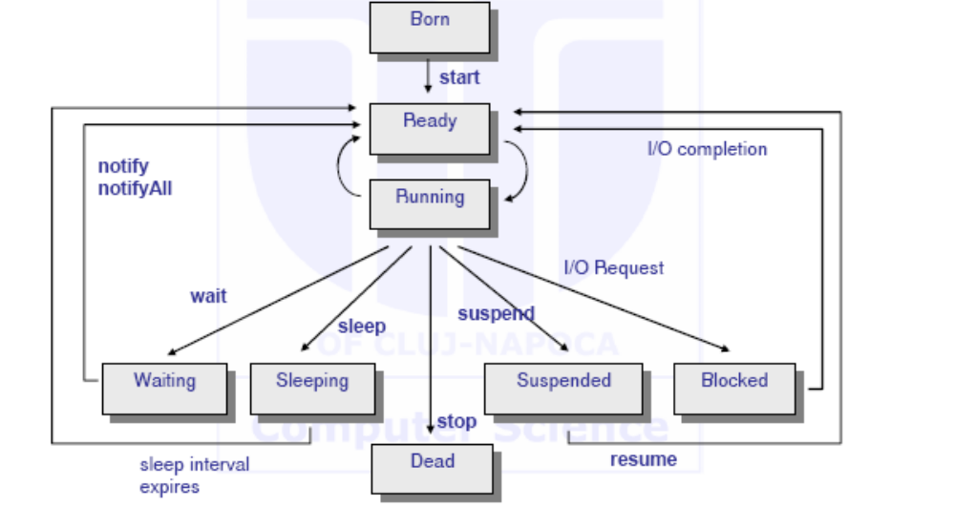

- How should one correctly terminate a Java thread?
A thread terminates when its run method terminates
_ Do not terminate a thread using the deprecated stop method
_ Instead, notify a thread that it should terminate
_ interrupt does not cause the thread to terminate – it sets a boolean field in the thread
data structure The run() method should check occasionally whether it has been interrupted
_ Use the interrupted method
_ An interrupted thread should release resources, clean up, and exit
public void run()
{
for (int i = 1;
i <= REPETITIONS && !Thread.interrupted(); i++)
{
Do work
}
Clean up
}
_ The sleep method throws an InterruptedException when a sleeping
thread is interrupted
_ Catch the exception
_ Terminate the thread
public void run() {
try {
for (int i = 1; i <= REPETITIONS; i++)
{
Do work
}
}
catch (InterruptedException exception) {
}
Clean up
}
_ Java does not force a thread to terminate when it is interrupted
_ It is entirely up to the thread what it does when it is interrupted
_ Interrupting is a general mechanism for getting the thread's attention

- What is a Java Collection?

- What are the main restrictions which apply to applets?
Applets run inside a “sandbox”
 Applet security manager protects the user
 Applets can NOT:
 Access files from the client machine.
 Create files on the client machine.
 Make network connects except back to the host machine where the applet came from.
 Start any programs on a client machine.
 Load libraries.
 Define native method calls.
 Halt execution of the interpreter (can't call System.exit()).
Can never run any client executable
 Cannot communicate with any host other than the server from which it came, “originating host”
 Cannot read or write to the client’s file system
 Can find out only limited info about the client machine:
 Java version in use
 Name and version of OS running
 Characters used as file and line separators
 Client language (English) & locale (Eastern Europe)
 Client currency (Euro)
 Windows popped up by an applet carry a warning message

- What are the differences between a standalone application and an applet?
An instance of the applet is always created, and its constructor, init, and start methods are
always run.
 Because an Applet instance is a Panel instance (and JApplet inherits from Applet), a visible component is created, awt events are (potentially) handled, etc.
 When a standalone application is invoked, only public static void main( String[] ) (and code called by it) is run.

- Describe the life cycle of an applet.
Every applet has 5 standard methods:
 init() — called by the browser when the applet is first loaded into memory
 start() — called by the browser to start animations running when the applet is made visible
 stop() — called by the browser to stop animations running when the applet is covered or minimized
 destroy() — called by the browser just before the applet is destroyed
 paintComponent() — called when the applet is drawn or re-drawn
Applet methods will always be called in the order init, start, stop, destroy – applet's life cycle
 start and stop may be called many times during the life of an applet

- What should be written in each of an applet's predefined methods?
 All 5 methods are implemented as dummy methods in class JApplet, and the dummy methods are inherited by all applets
 Applets override only the methods that they need to perform their function
 An applet has a status window
 Informs you of what the applet is currently doing
 To output to the status window use showStatus method with aString argument

- What are the top level containers for GUIs in Java?
The classes JFrame and JPanel are descendent classes of the class Container. Therefore they and any of their descendents can serve as a container

- What are Java threads?
Thread: a single sequential flow of control within a program (also called lightweight process).
_ parallel processes running inside of a program
_ in Java you can create one or more threads within your program just as you can run one or more programs in an operating system
_ Java: create threads in two ways:
_ A class extends the Thread class and overrides it's run() method.
_ A class implements the Runnable interface, which has one method: run().
_ The class passes a reference to itself when it creates a thread.
_ The thread then calls back to the run() method in the class.

- What are the differences between threads and operating system tasks?
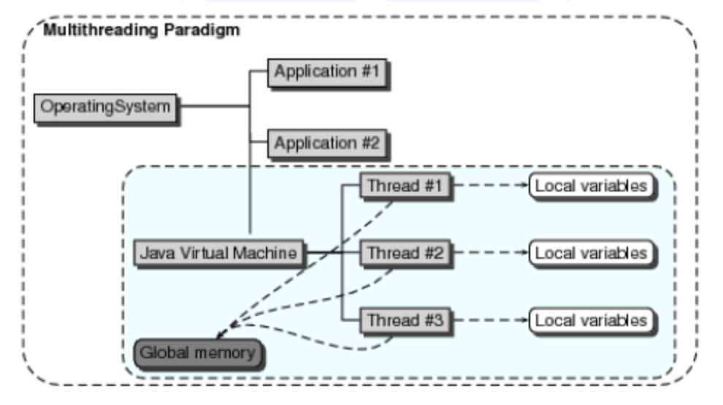
Multitasking is a method by which multiple tasks, also known as processes, share common processing resources such as a CPU. A thread of execution is the smallest unit of processing that can be scheduled by an operating system. It generally results from a fork of a computer program into two or more concurrently running tasks. The implementation of threads and processes differs from one operating system to another, but in most cases, a thread is contained inside a process. Multiple threads can exist within the same process and share resources such as memory, while different processes do not share these resources. In particular, the threads of a process share the latter's instructions (its code) and its context (the values that its variables reference at any given moment). Multithreading extends the idea of multitasking into applications, so you can subdivide specific operations within a single application into individual threads.
- What is a factory method? Give a brief example.
Factory methods are static methods that return an instance of the native class.
Factory methods :
- have names, unlike constructors, which can clarify code.
- do not need to create a new object upon each invocation - objects can be cached and reused, if necessary.
- can return a subtype of their return type - in particular, can return an object whose implementation class is unknown to the caller. This is a very valuable and widely used feature in many frameworks which use interfaces as the return type of static factory methods.
Common names for factory methods include getInstance and valueOf. These names are not mandatory - choose whatever makes sense for each case.
Example

public class ComplexNumber {

/**
* Static factory method returns an object of this class.
*/
public static ComplexNumber valueOf(float aReal, float aImaginary) {
return new ComplexNumber(aReal, aImaginary);
}

/**
* Caller cannot see this private constructor.
*
* The only way to build a ComplexNumber is by calling the static
* factory method.
*/
private ComplexNumber (float aReal, float aImaginary) {
fReal = aReal;
fImaginary = aImaginary;
}

private float fReal;
private float fImaginary;

//..elided
}

